# DNCS Utilisation Sheet – Process and Logic

Files Used

Examples can be found [here](http://elsevierit/sites/UKCP/CPM%20Work/Forms/AllItems.aspx?RootFolder=%2fsites%2fUKCP%2fCPM%20Work%2fDCNS%20Monthly%20Sheets%2fDNCS%20Util%20sheet%20%2d%20Marcelle&View=%7bCB820616%2d5C29%2d40A2%2dB709%2d8D2382FFD986%7d).

Katie_DDMMYYY – provided by Gordon Galloway at the beginning of each month

CR_YYYY-MM-DD – Automated report set up by Hazy Mathews

dMMDDYY_all – Automated report setup by Mike Natale

DCNS Sheet Amendments MMM DD YYYY.xlsx – Set up by Katie Jenner

MMM YYYY DCNS Storage Util sheet – Set up by Katie Jenner

Pre work

The DCNS information is provided each month by Gordon Galloway in the Katie_DDMMYYY file. This needs to have column I, vcBSLPath, split into 4 separate columns with the delimiter being ‘|’.

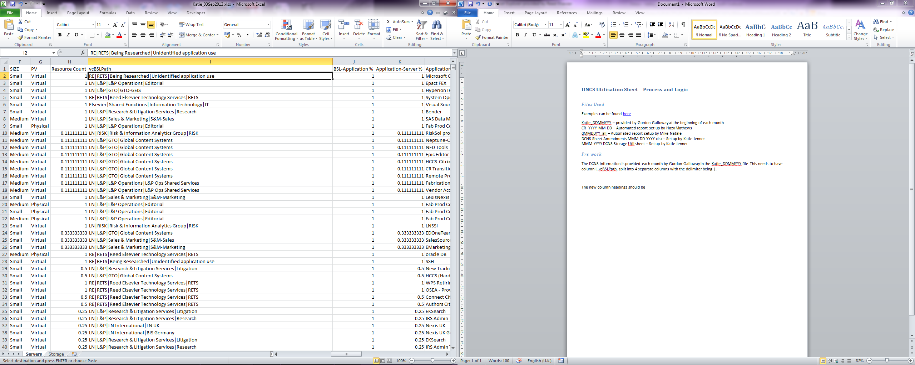

The new column headings should be as below:

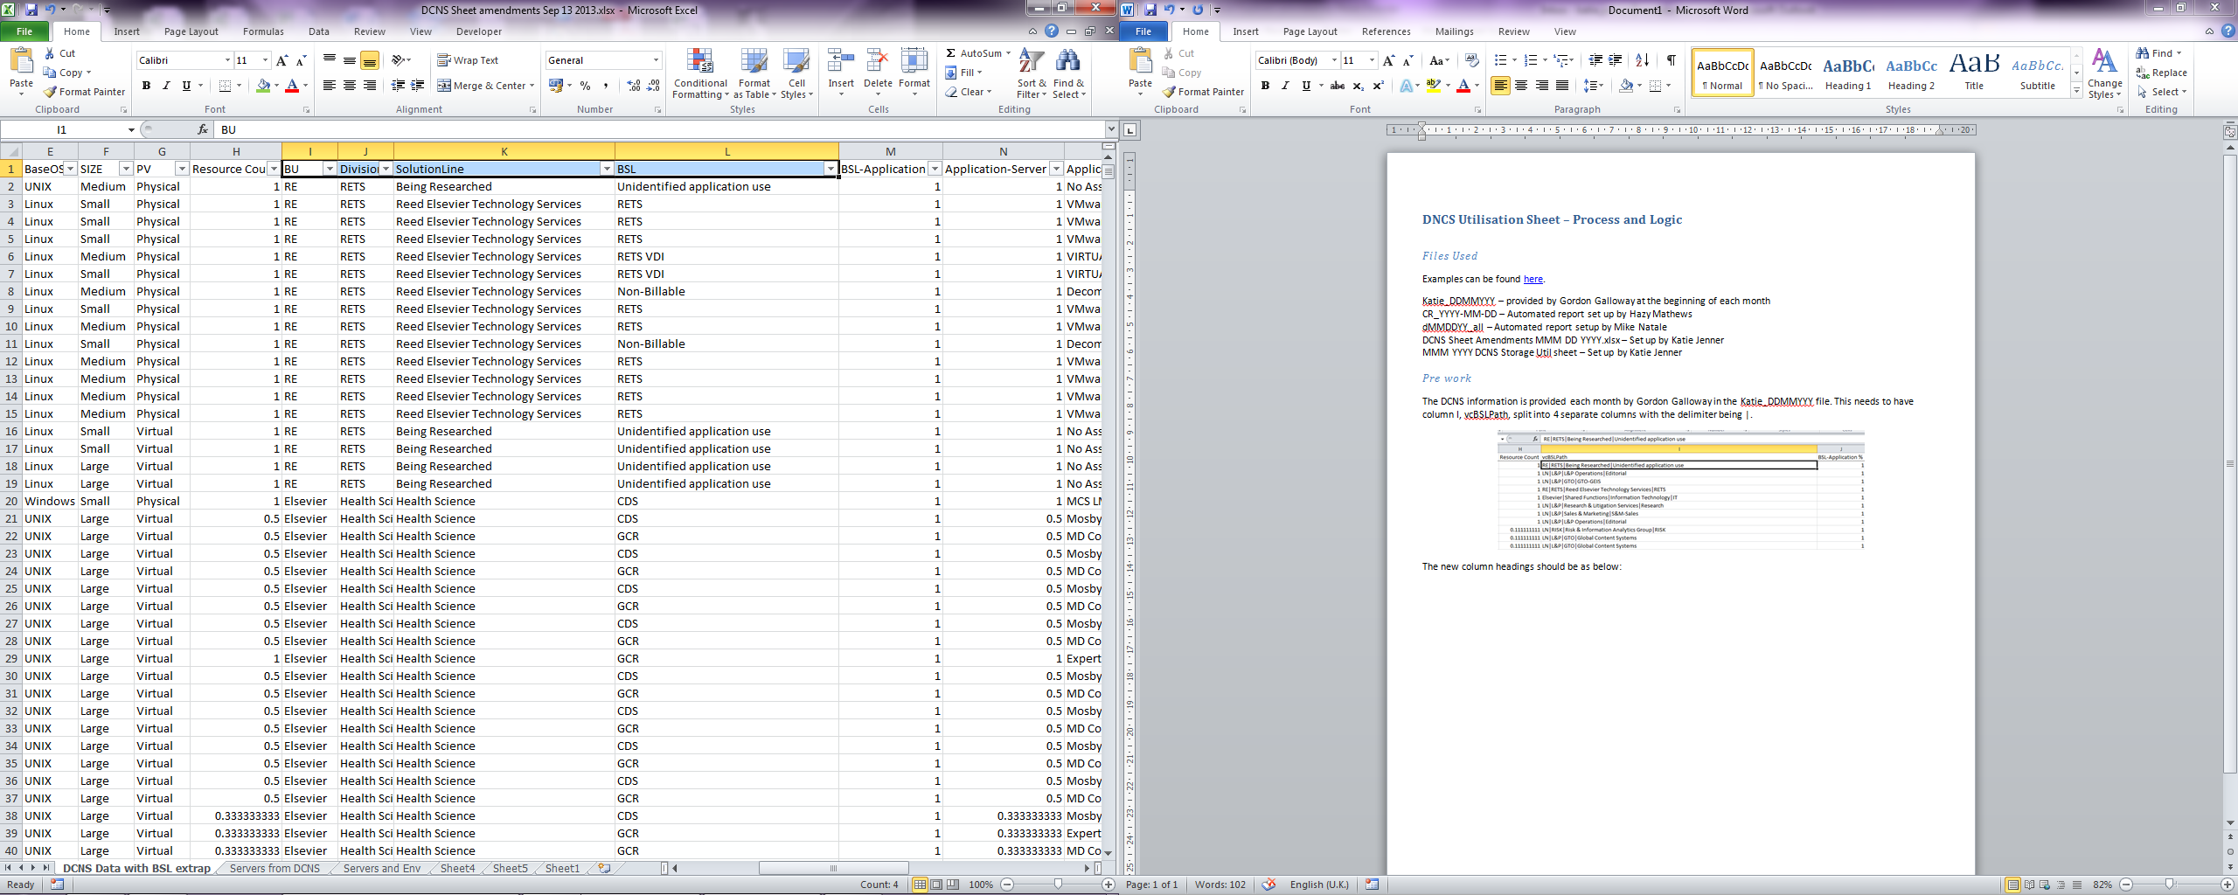

All of this data then gets put into the DCNS Sheet amendments MM DD YYYY.xlsx, in the *DCNS Data with BSL extrap* tab. From here the server list is deduped and pasted into the *Servers from DCNS* tab and *Servers and Environment* tab.

The *Servers from DCNS* tab is there to check that a server marked as physical does not contain the word Virtual in the Server Model. If it does column F changes it to virtual, if it does not then the original is pulled through from column C.

The *servers and Env* tab runs through a series of IF statements to determine whether a server is Prod, Dev, Cert, Test, DR etc. The following table is a breakdown of those if statements:

|  |  |  |  |
| --- | --- | --- | --- |
| **Server Name** | **…** | **Environment returned** | **Example** |
| Contains | dev | Dev | Appdev2 |
| Contains | int | Int | Intd3bapp02b |
| Contains | prod | Prod | Webspprod1 |
| Contains | prd | Prod | Asappprd1 |
| Contains | cert | Cert | Certhome1 |
| Contains | crt | Cert | Asappcrt1 |
| Contains | test | Test | Cbstest5 |
| Contains | uat | UAT | cispyuat |
| Starts with | Drp | DR | drprac002b |
| Starts with | Drlp | DR | drlpinf001v |
| Contains | Clup | Prod | elsamsclup02p1 |
| Contains | Clud | Dev | elsoxfclud01p2 |
| Contains | Cluc | Cert | elsoxfcluc01p2 |
| Contains | Clua | Cert | elsoxfclua01p1 |
| Contains | clut | Test | retoxfclut01p2 |
| Starts with | pnt | Prod | pntd2bapp109a |
| Starts with | Psc | Prod | psc111619 |
| Starts with | Psdb | Prod | psdb111109 |
| Starts with | Psml | Prod | psmlb4406 |
| Starts with | P1ml | Prod | p1mlw-cr02 |
| Starts with | P1se | Prod |  |
| Starts with | Dvd | Dev | dvdb77547 |
| Starts with | dvc | Dev | dvc88602 |
| Starts with | Lab | Lab | lab77227 |
| Starts with | Tpdb | Test | tpdb22519 |
| Starts with | Tpc | Test | tpc87770 |
| Starts with | Tpw | Test | tpweb4401 |
| Starts with | tpn | Test | tpn3005 |
| Starts with | Oxp | Prod | oxpaps16a |
| Starts with | oxlp | prod | oxlpora002 |
| Starts with | Oxc | Cert | oxcaps39a |
| Starts with | Oxlc | Cert | oxlcrac001a |
| Starts with | Oxd | Dev | oxdaps24l |
| Starts with | Oxld | Dev | oxldora004v |
| Starts with | Oxt | Test | oxtaps61bl2 |
| Starts with | Oxlt | Test | oxltaps001v |
| Starts with | Cnt | Cert | cntd1b0101 |
| Starts with | Cpweb | Cert | cpweb1473 |
| Starts with | Cpml | Cert | cpml1a662 |
| Starts with | Cpn | Cert | cpn2003 |
| Starts with | Cpdb | Cert | cpdb111174 |
| Starts with | Cpc | Cert | cpc111743 |
| Starts with | Cltukp | Prod | cltukpapp6 |
| Starts with | Clleb | DR | cllebapb4 |
| End with | P and 3 numbers | Prod | elsamsbesp002 |
| Ends with | C and 3 numbers | Cert | elsda2appc001 |
| Ends with | D and 3 numbers | Dev | elsda2appd005 |
| Ends with | T and 3 numbers | Test | elsoxfappt081 |
| Ends with | A and 3 numbers | Cert |  |
| Starts with | C and a number | Cert | c1sde-ds01 |
| Starts with | Cl | Cert | clsdevmnts2 |
| Starts with | Cp | Cert | cpc1673 |
| Starts with | D and a number | Dev | d1mkp-as01 |
| Starts with | Dv | Dev | dvwebz7452 |
| Starts with | Dco | Dev | dcops4 |
| Starts with | P and a number | Prod | p1mde-as01 |
| Starts with | Ps | Prod | psc11817 |
| Starts with | T and a number | Test | t4-01-dc1-ld2 |
| The 4th, 5th & 6th letters are | Red | DR | retredbesp010 |
| The 4th, 5th & 6th letters are | Wkg | DR | rehwkgappp001 |

More than one rule can apply to a single server and at the moment I have to make a manual judgement call. To maintain consistency month to month, I also compare last month’s list of servers/environments to the one generated by the spreadsheet for the current month and override the current month with last month’s if it is different.

There are also a large number of servers that I cannot make out an environment for based on the above rules. These will need to be rectified somehow.

Once all of this has been done all of the data then gets consolidated into the Applications tab of the MMM YYYY DCNS Storage Util sheet.

The de duped server list gets put into the Server and Util sheet tab, and the Servers and Allocated Storage tab. Both of these tabs then populate a number of columns based on vlookups on the Applications tab e.g. environment BSL and whether the server is shared or not.

The Server and Util tab is further fed by inputs from Mike Natale and (for the time being) Hazy Mathews. Mike provides the dMMDDYY_all.csv file, which includes the max peak each week for CPU for most servers across the Windows, Unix and Linux platforms and Hazy’s (CR_YYY-MM-DD) provides the UK windows CPU (amongst other things). These 2 sheets have to be consolidated (Mike’s data needs to be multiplied by 100 to match Hazy’s) and then matched with the server names in the Server and Util sheet. There should be 52 weeks of data. At the far end of this data range are a number of calculated columns.

|  |  |
| --- | --- |
| **Column Name** | **Description** |
| Monitored in the last week? | IF statement – if the last cell for the utilisation data has – in it return nothing, if it does not return 1 |
| All dates Avg | AVERAGE – returns the average of the last 52 weeks |
| Feb Avg | AVERAGE – returns the average of the February dates (manually chosen) |
| Mar Avg | AVERAGE – returns the average of the March dates (manually chosen) |
| Apr Avg | AVERAGE – returns the average of the April dates (manually chosen) |
| May Avg | AVERAGE – returns the average of the May dates (manually chosen) |
| Jun Avg | AVERAGE – returns the average of the June dates (manually chosen) |
| Jul Avg | AVERAGE – returns the average of the July dates (manually chosen) |
| Aug Avg | AVERAGE – returns the average of the August dates (manually chosen) |
| MMM Avg | As above for future months |

The Servers and Allocated Storage tab is fed by a sheet prepared by Gordon Galloway, now part of the Katie_DDMMYYY. The servers are matched in both sheets and the data copied across into the Servers and Allocated Storage tab.

The pivot tables in the Pivots tab are refreshed once all this has been done. The pivot tables cover:

* The average CPU usage for each OS by Environment
* The total Storage/ GB for each Tier by environment
* The number of physical servers and the number of virtual servers
* The number of physical and virtual servers by business unit
* The number of servers (and a list of server names) with no associated application
* The monthly cpu averages for each division by site
* The number of total servers and servers monitored for LN by Domain and OS

There are other requests throughout the month and Andrew Lloyd requires the physical and virtual total numbers as well as the number of servers monitored for LN each month.